**Requirements and Use Case of Intersection Infrastructure of Cross Road Scenario**

**Requirement:** When it comes to the needs, first and foremost, we must establish an infrastructure architecture based on our understanding of the autonomous vehicle's operation. Only then can a safe crossroad infrastructure be developed.

**Functional Requirements:**

1. Setting upcycle length for infrastructure.
2. Phase Setting for the different cycles.
3. Looking for obstacles.
4. Traffic light autonomous maintenance.
5. Watch Traffic in the same direction.
6. Drive direction setup.
7. Maintain traffic policies.

**Non-Functional Requirements:**

1. Handle accidental cases.
2. Secure the system from third-party interference.
3. Take action on breaking the law.

**Use Case Diagram:** This diagram depicts the infrastructure that will be used to handle traffic in the intersection for autonomous vehicles utilizing a queueing system. The entire infrastructure is dependent on the actions of cycle and phase setup, which will manage traffic control scenarios. Autonomous drivers must identify obstacles by observing 360-degree views while driving, and system monitoring and legislation construction must be done quickly to keep the process rolling.

**Actors:**

* Traffic Light
* Autonomous Drivers
* Intersection
* Autonomous Monitoring
* Traffic Law

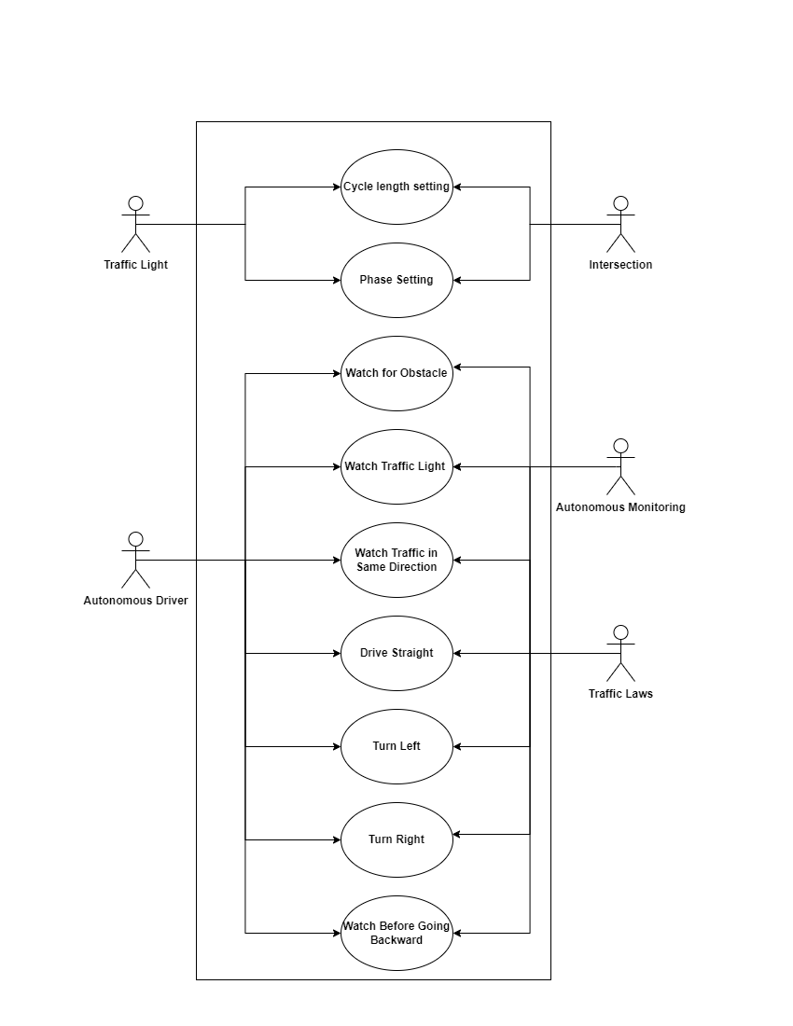

**Figure:** Initial Use Case Diagram of The Intersection Infrastructure